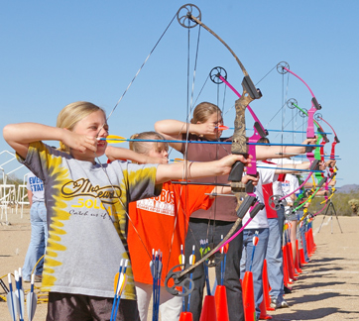

Buckeye Outdoors Youth Education & Shooting Center’s
2019 Youth Archery Program
When
Mondays (Levels 1) & Wednesdays (Levels 2 & 3)
6:00pm

Begins Concludes
Monday, August 12 Monday, September 23
(Closed on Labor Day)

Where
Copley Trap Range property
1665 Jacoby Rd.

Cost
$25
Includes use of bows, arrows, targets
T-shirt and trophies by age group

Program Format: All youth are invited as long as they can pull back one of the youth bows safely. Youth will be divided by ability. We offer a three level format. Phase 1 is basic instruction for the new archer. Phase 2 is for archers with their own or one of our compound bows who want individualized instruction shooting at bags and some 3-D targets. Phase 3 will be shooting at 3-D targets.

An indoor archery clinic/safety class is required for all first year participants. The class will be conducted first night on Monday, August 12, 5:00 – 6:00pm, followed by our first league night at the Range Clubhouse located at 1665 Jacoby Rd., Copley.

Registration is limited and all participants must have a consent & waiver form on file.

For more information and registration, please contact Jason Drerup 330-441-2312.
Archery Program Phases
Course Length
Length of the program will be 6 weeks long - 4 weeks of instruction and 2 weeks for score (phases 1 & 2). Bows are available for all phases, if needed. Program conducted during the months of August and September.
Classroom Instruction
Before archery instruction begins we will have a mandatory class on safety and proper archery form for all new archers to our program. This class will only need to be attended one time.
Bow fitting and tuning: Will be by appointment on non-league nights or as time allows on shoot night.
Phases of Instruction
Phase 1 - Beginners
First year shooters using BOYESC equipment will shoot at the bag targets to learn the skills needed to advance to Phase 2. First year shooters with their own equipment will start on bag targets and may advance to Phase 2 if they can prove skill level needed to advance.
To advance to Phase 3 you must be able to consistently hit an 8" circle at a distance of 20 yards. This does not mean every arrow has to hit a 8" circle, just the majority of the time.
Trophies given by following divisions: Cub 10-12 years, Youth 13-14, Youth 15-18, Lady

Phase 2 - Intermediates
At this phase the archer will be shooting at bag targets and 3-D animal targets. Targets will be placed at known distances out to 25 yards. Most shooters will be using compound bows with releases. Bows will be tuned to the shooter with proper form and technique emphasized.
Trophies given by following divisions: Intermediate, Intermediate Lady
Phase 3 – 3-D Course
At this Level the archer will be shooting at 3D targets at known and unknown distances out to 35 yards. Instructors will help archers learn how to judge yardages and the importance of shot placement.

